**Tutorial 04 –** Build WordPress CMS on Multiple Platforms and using Best Practices, extend with images, menus, themes, pages, posts, categories, tags, and plugins.

Students are required to have access to a Web Host account that they use to create and manage multiple CMS websites.  
  
If you have difficulties completing this assignment, please inform the instructor and consider working with DePaul tutors.

**Instructions for completing template:***Replace* **[bracketed red text]** *with the requested information.  
Do not include full screen shot images, or full screen shots that are reduced in size. Use a snippet tool to capture parts of the screen and insert those images into the template.  
  
Please answer all questions.***Please do not alter this template numbering.  
Each answer and screen capture are worth equal points.**

**PART A – Getting started Student Contact Information**

**1. Student Name: Abel Marin [A01]**

**2. Student Contact Information:   
marinabe1416@gmail.com [A02]   
(630) 608-8570 [A03] *OPTIONAL**

**Go back to the tutorial instructions and begin working on part B.**

**Part B.1 – For WordPress site on a shared web host [B.1]**

1. Enter the following shared web host WordPress site information
   1. Shared Web Host Company Name: [ SiteGround ]
   2. Shared Web Host account username: [ [amarin13@mail.depaul.edu](mailto:amarin13@mail.depaul.edu) ]
   3. Shared Web Host password: [ Dbeu!315 ]
   4. Website Admin Username: [ uwr5x]
   5. Website Admin Password: [ @q%3DQWnmK]
   6. Database Name: [ wp260 ]
   7. Table Prefix: [ wprj_ ]
   8. WP website URL: [ <http://abelm.sgedu.site/tutorial04> ]

**Part B.2 – For WordPress site on Pantheon (PaaS) [B.2]**

1. Enter the following shared web host WordPress site information
   1. PaaS WordPress Front-end site URL: [ website URL here ]
   2. PaaS Web Host account username: [ account username here ]
   3. PaaS Web Host password: [ account password here ]
   4. PaaS WordPress site Admin Username: [ website admin username here ]
   5. PaaS WordPress site Admin Password: [ website admin password here ]

**Part B.2 – For WordPress site on Codeanywhere [B.3]**

1. Enter the following shared web host WordPress site information
   1. Codeanywhere account username(email): [ marinabe1416@gmail.com ]
   2. Codeanywhere account password): [ Dbeu!315 ]
   3. Tutorial WP Site URL: [ <https://amjtutorial4ca-marinabe1416545968.codeanyapp.com/> ]
   4. WordPress site Admin Username: [ ajmarin ]
   5. WordPress site Admin Password: [ $FfWI$RZUdut2XqieM ]

**Go back to the tutorial instructions and begin working on part C.**

**Part C –** Flesh out the WordPress site with Images, a theme, and a menu, pages, posts, category and tags.  
**Please make sure all Part C screen capture include the web browser address bar. [C]**

1. Take screen captures of the backend administration WordPress site Dashboard   
   **[C.1]  
   [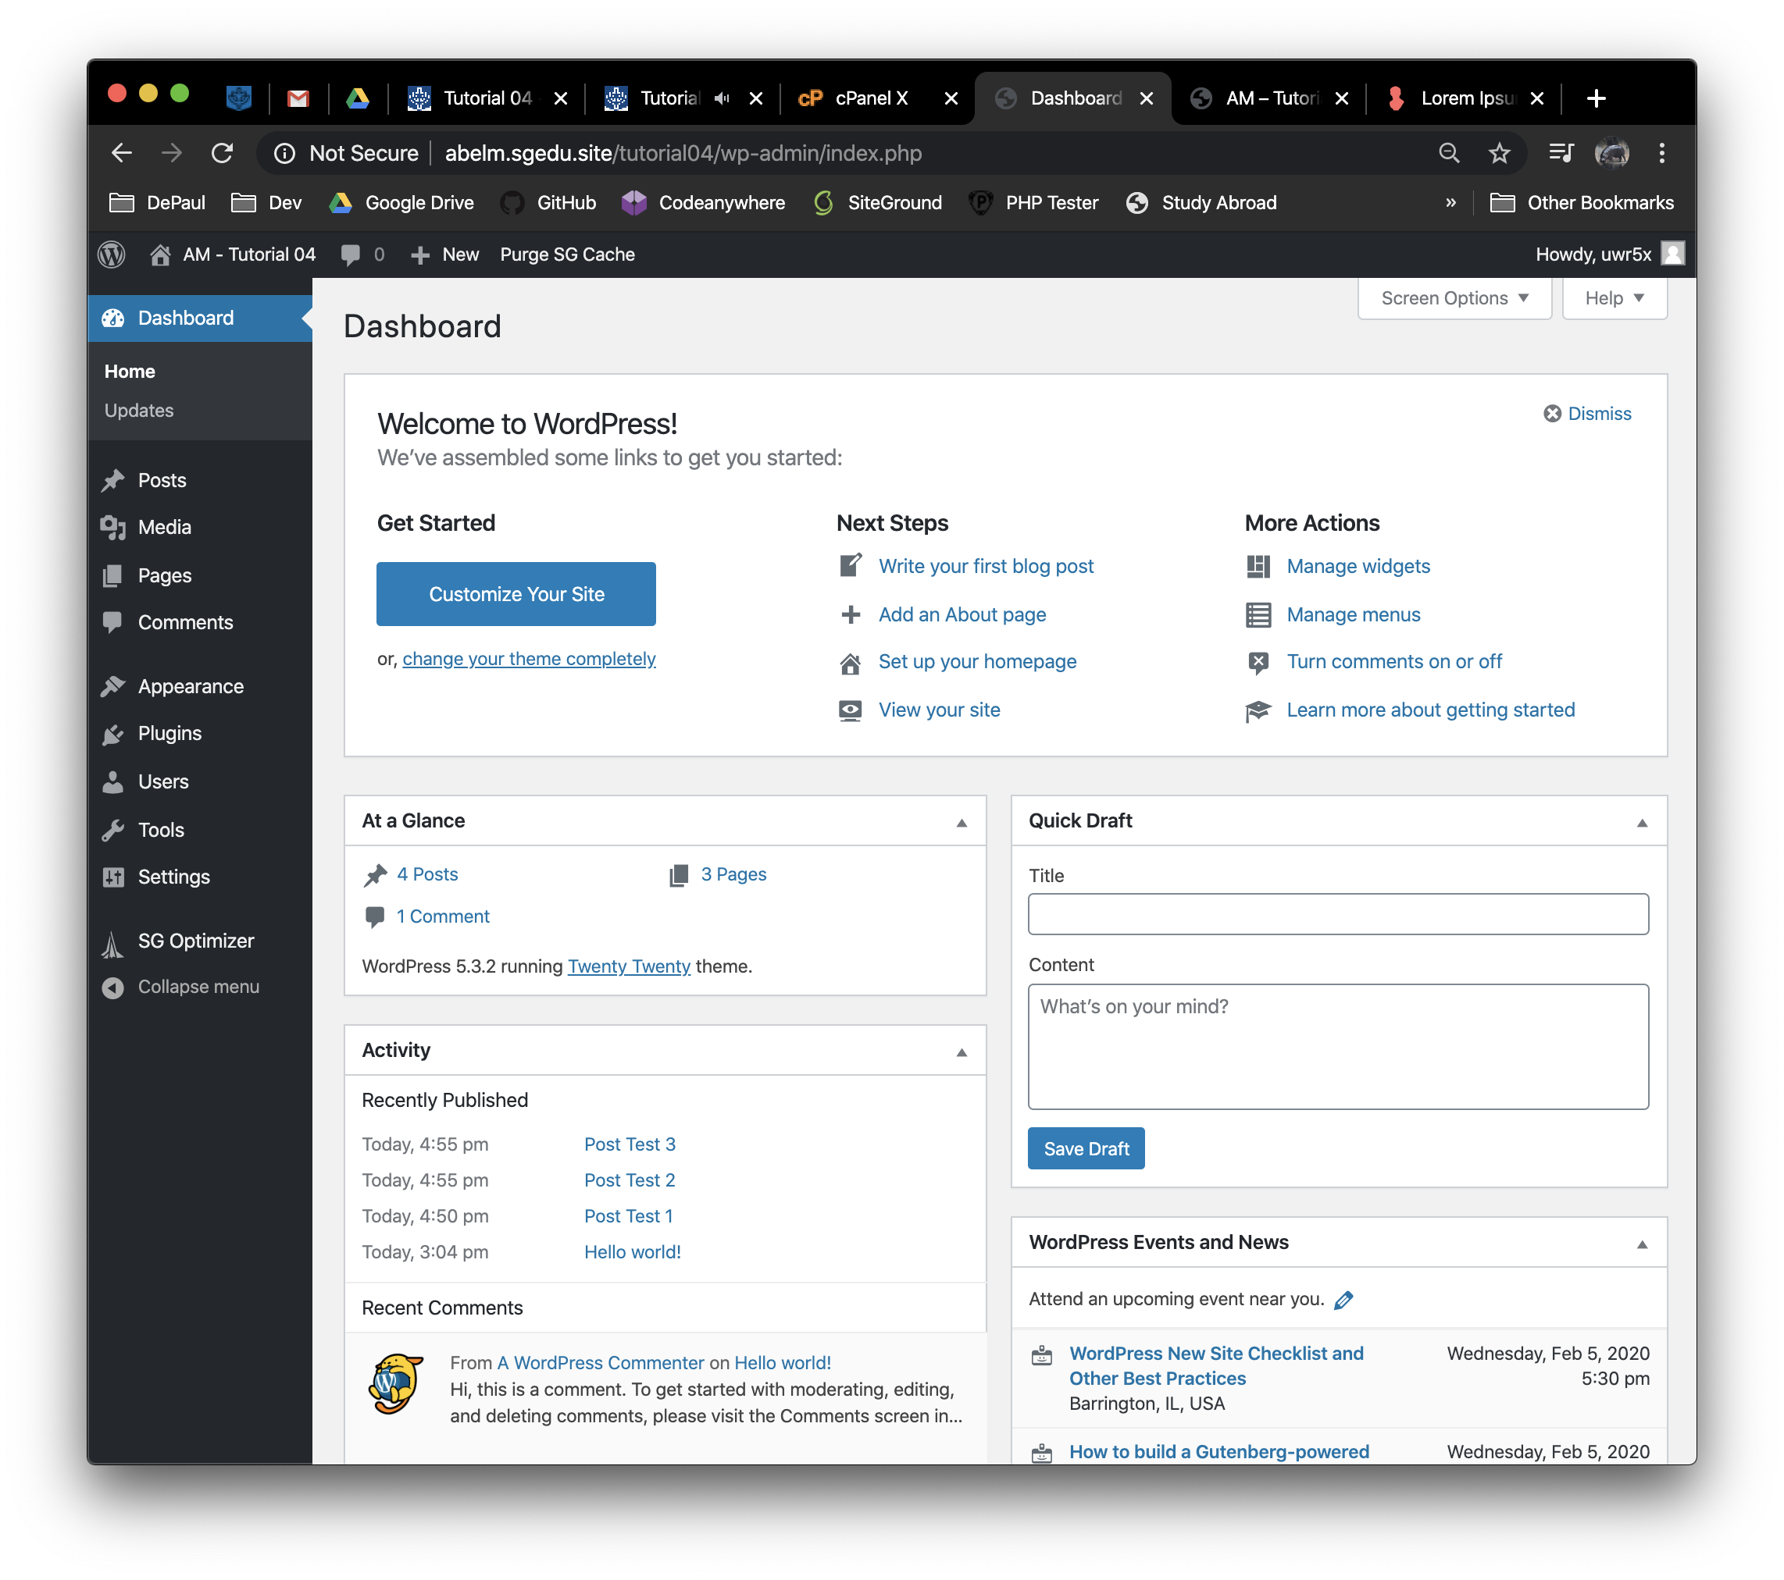]**
2. Take screen captures of the backend administration WordPress site Dashboard > Appearance > Media page – with the media library in GRID mode   
   **[C.2]  
   [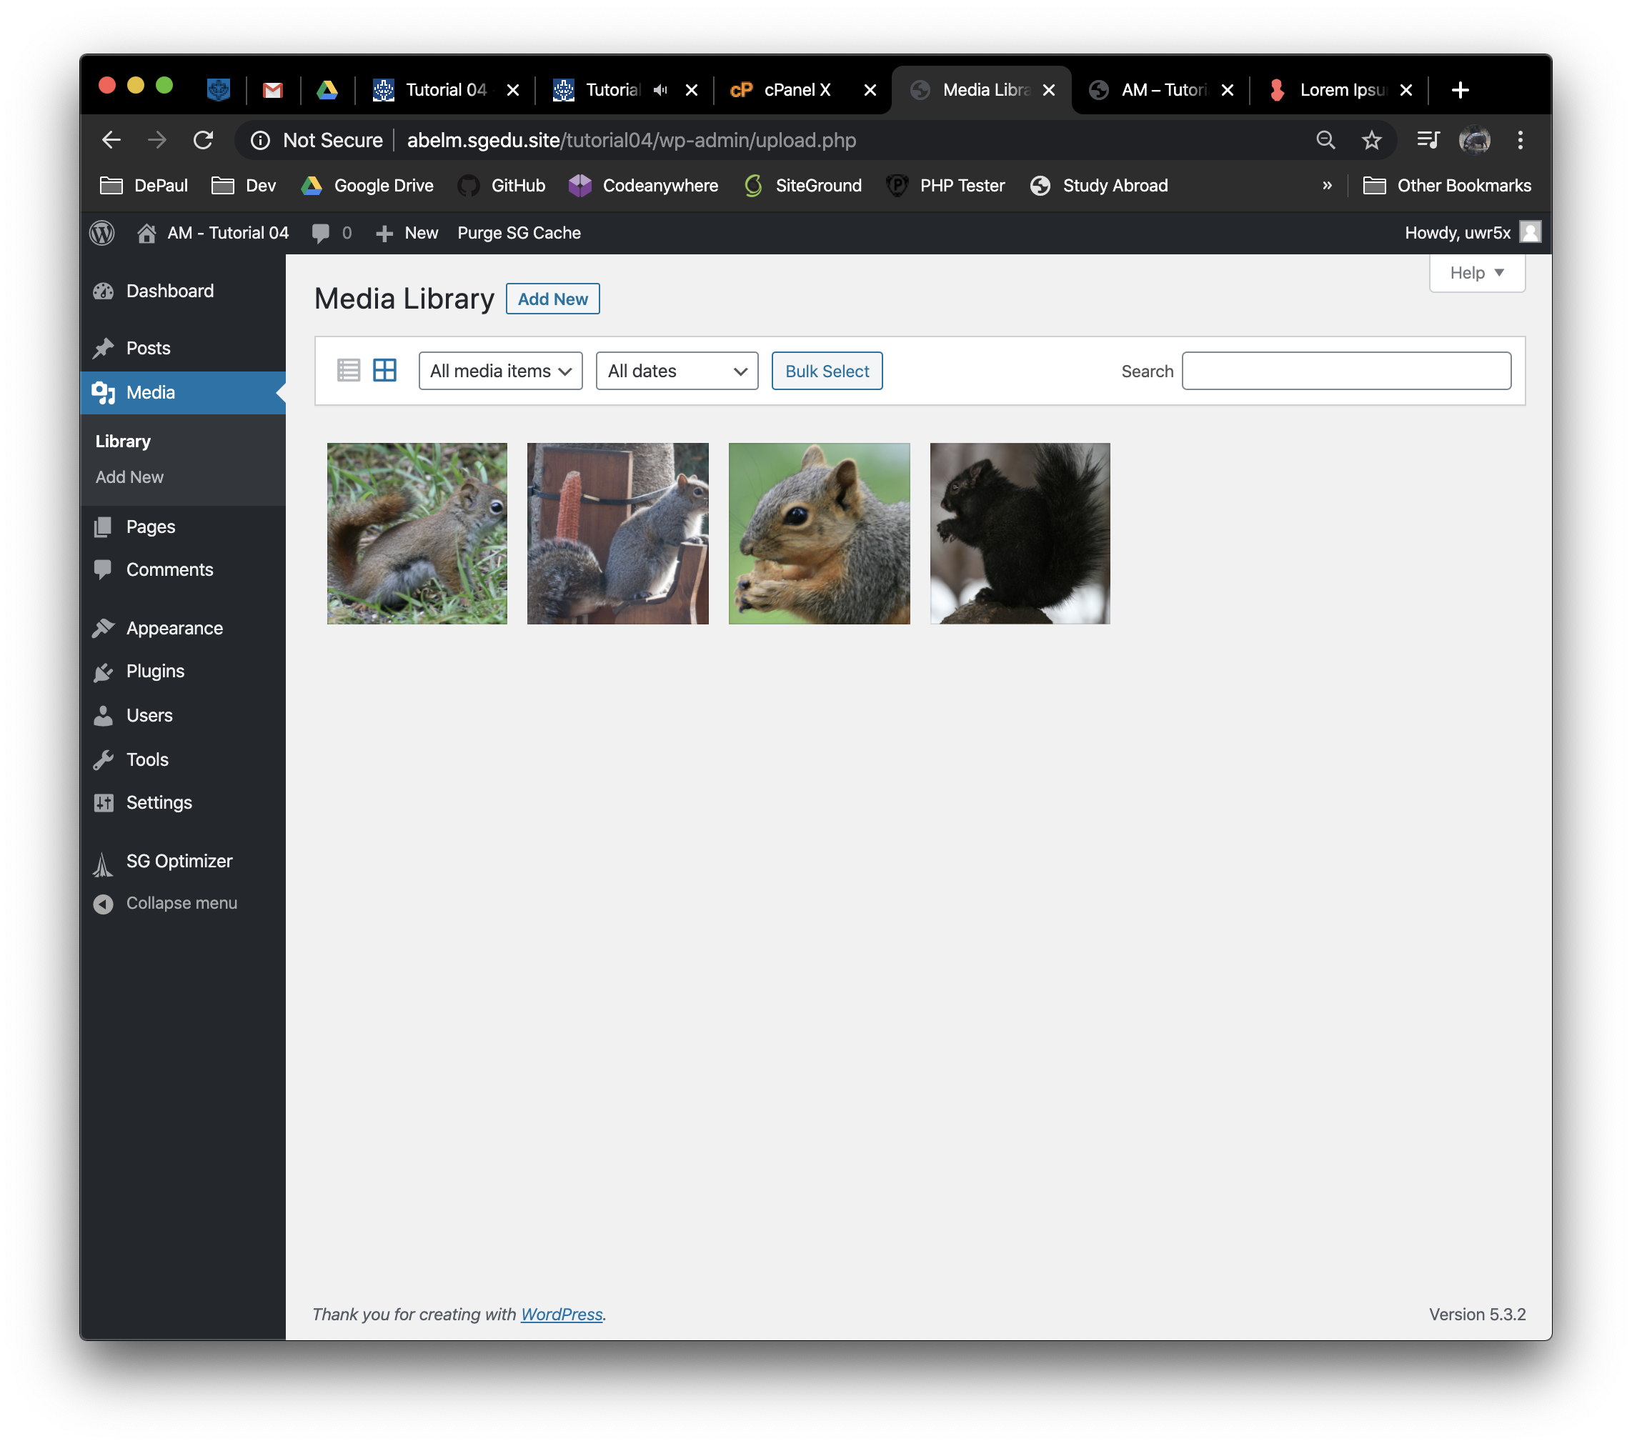]**
3. Take screen captures of the backend administration WordPress site Dashboard > Appearance **[C.3]  
   [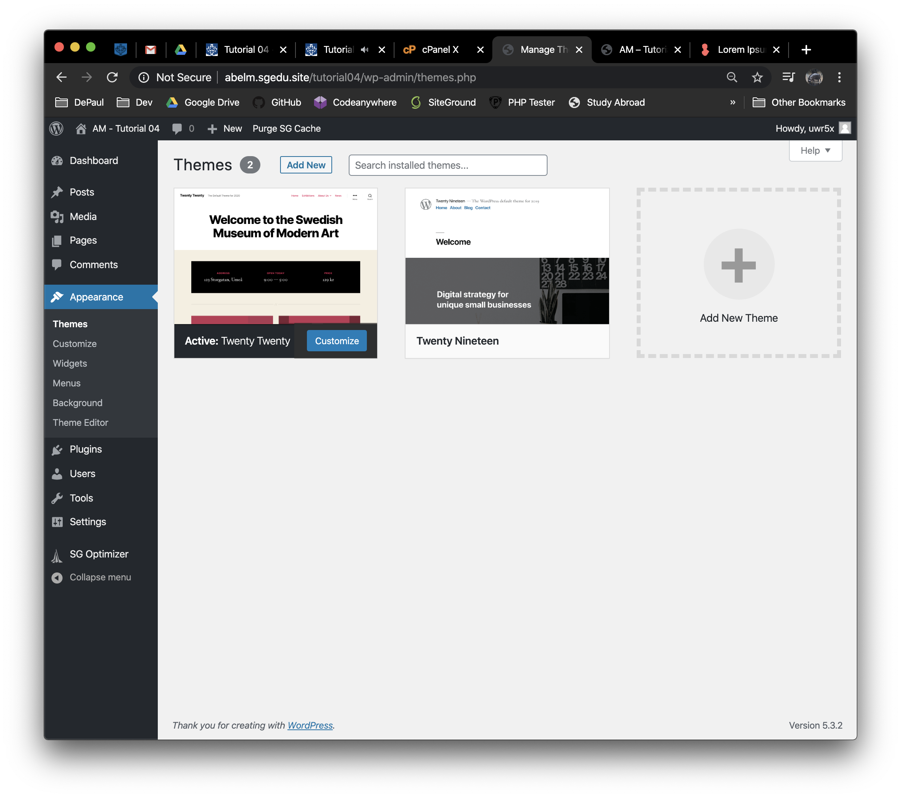]**
4. Take screen captures of the backend administration WordPress site Dashboard > Appearance > Menus   
   **[C.4]  
   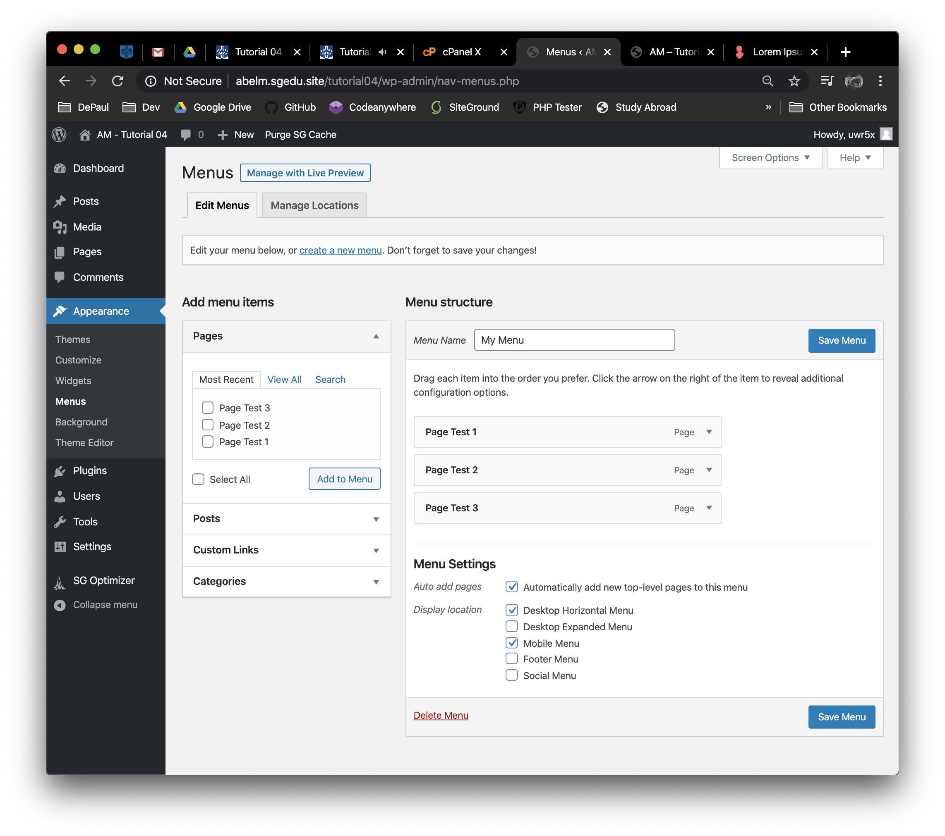[]**
5. Take screen captures of the backend administration WordPress site Dashboard > Pages   
   **[C.5]  
   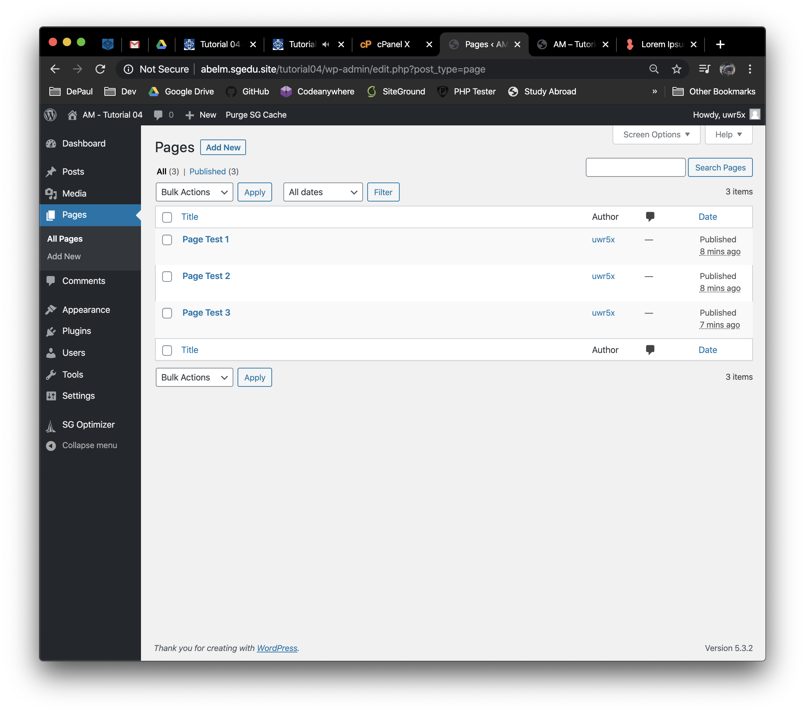[]**
6. Take screen captures of the backend administration WordPress site Dashboard > Posts > Categories  
   **[C.6]  
   [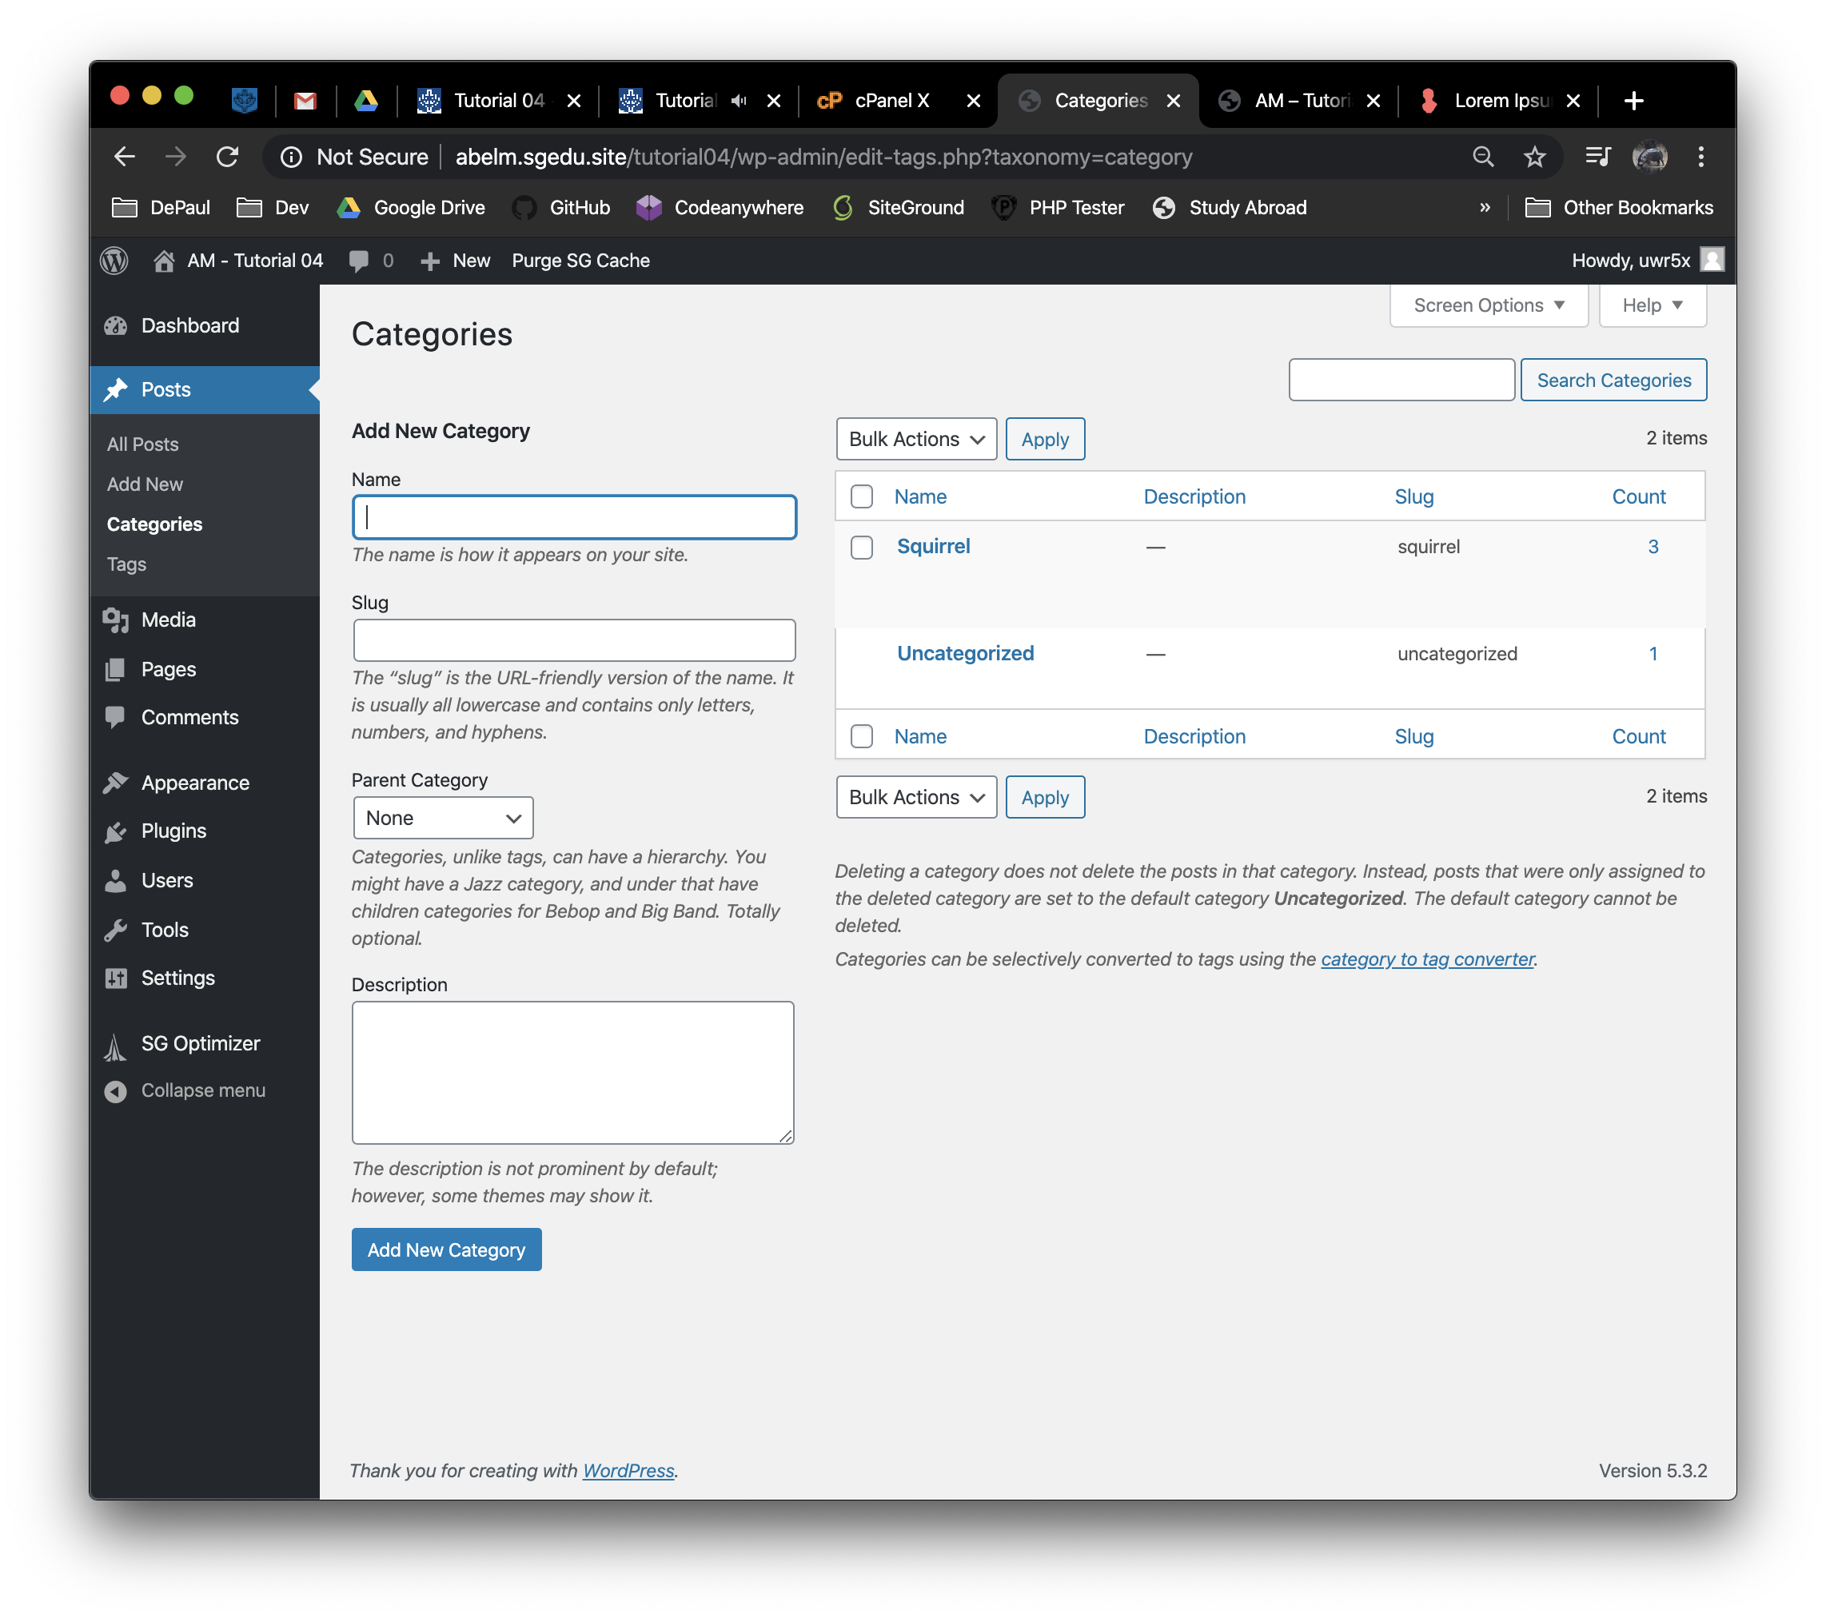]**
7. Take screen captures of the backend administration WordPress site Dashboard > Posts >Tags   
   **[C.7]  
   [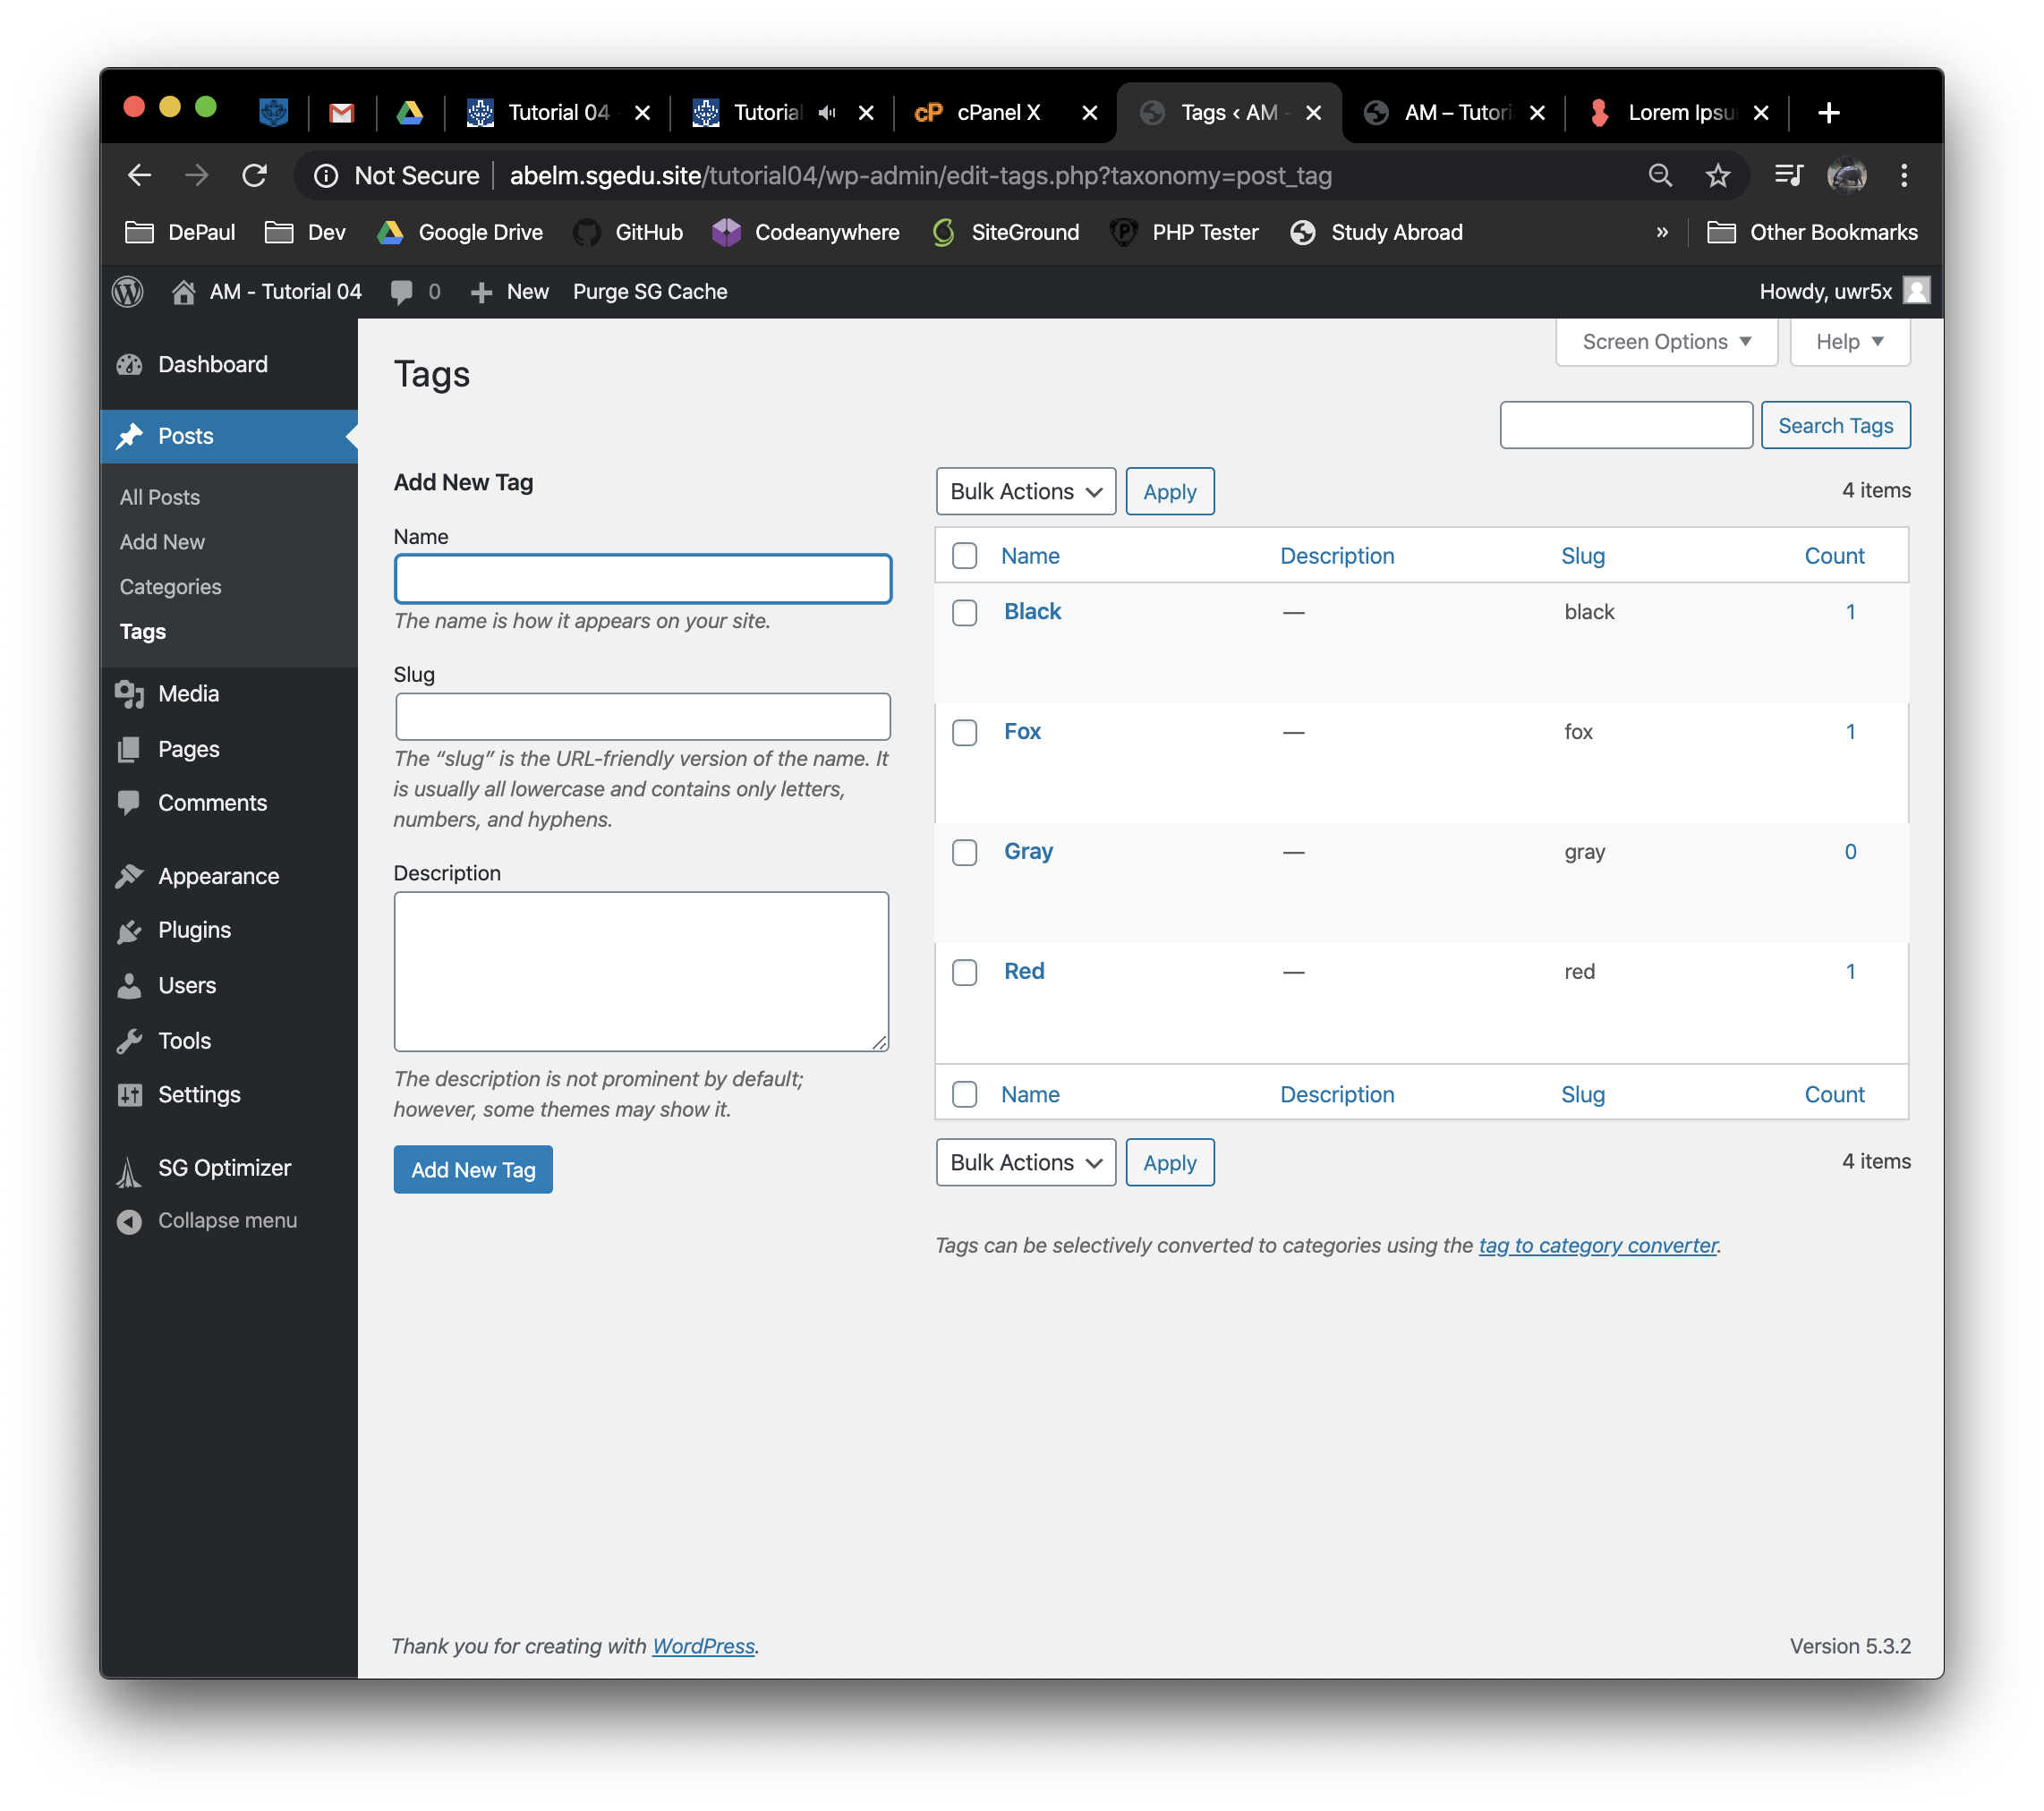]**
8. Take screen captures of the backend administration WordPress site Dashboard > Posts   
   **[C.6]  
   [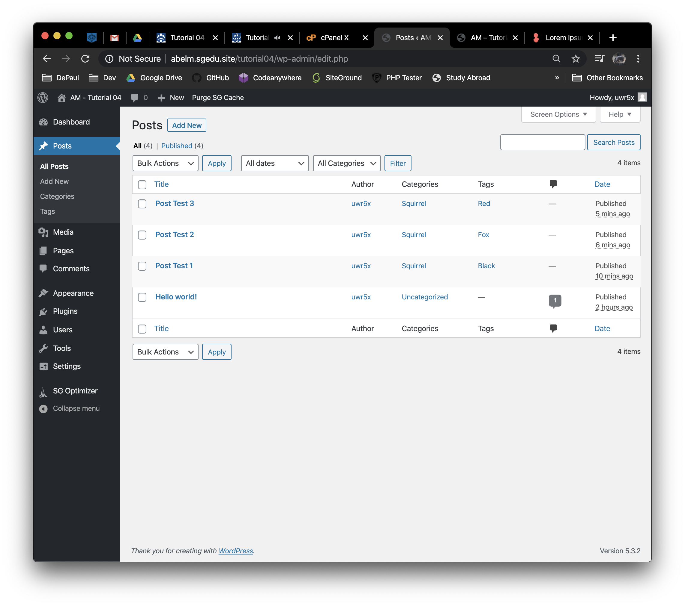]   
   Go back to the instructions and continue at Part D.**

**Part D – Extend WordPress with Widgets**

**Please make sure all Part D screen capture include the web browser address bar. [D]**

1. Take screen captures of the backend administration WordPress site Dashboard > Appearance > Themes **[D.1]  
   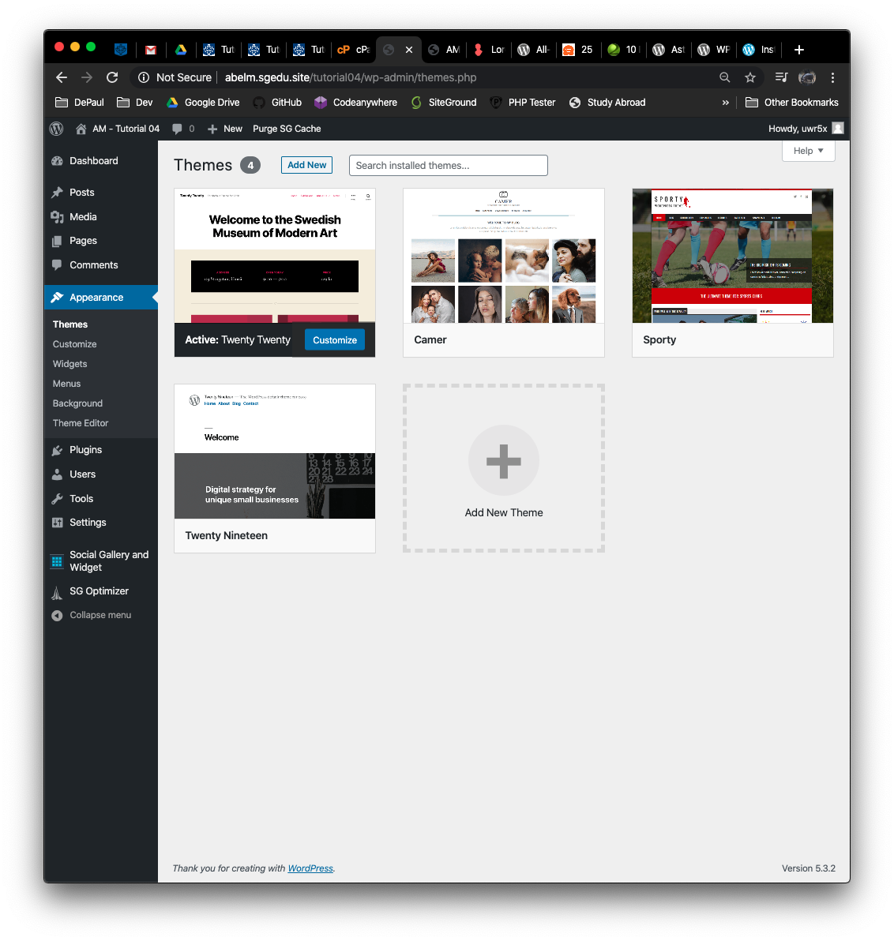[]**
2. Take screen captures of the backend administration WordPress site Dashboard > Plugins > Installed Plugins – showing the installed and activated Widget Plugins **[D.2]  
   [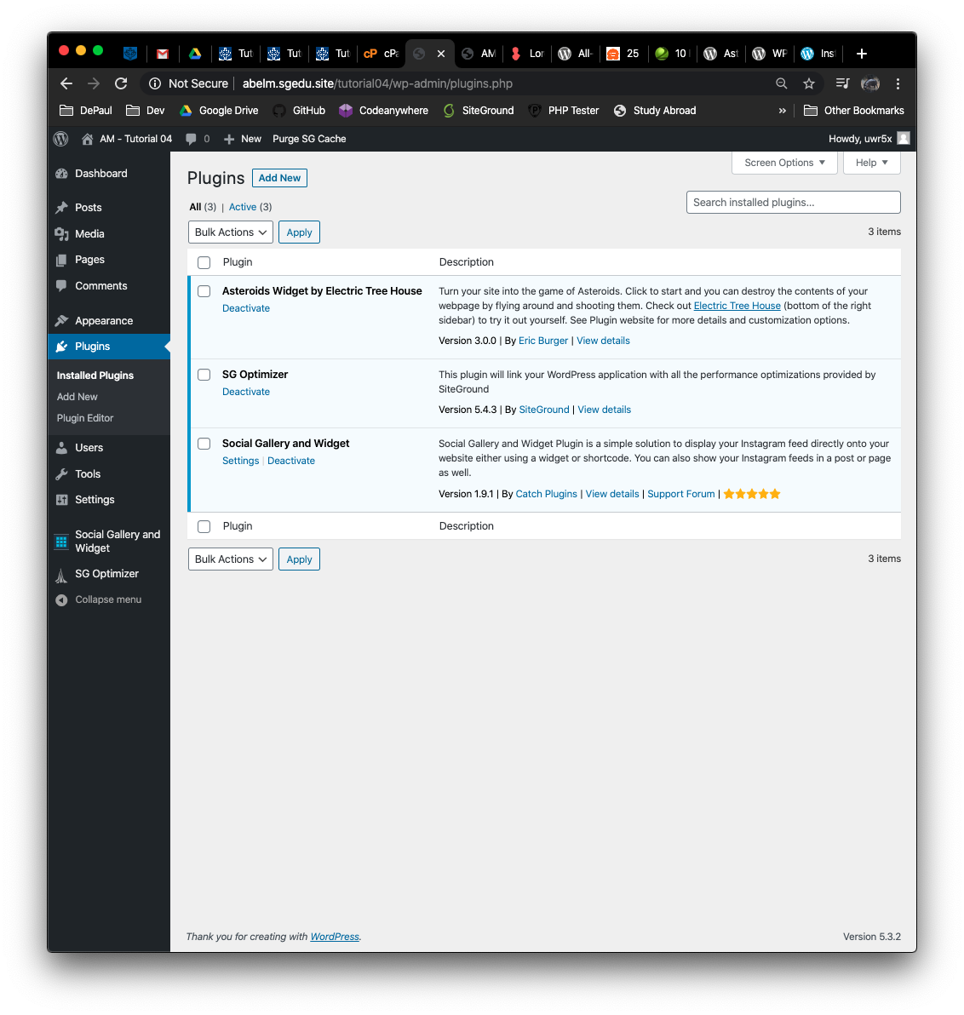]**
3. Take screen captures of the backend administration WordPress site Dashboard > Appearance > Widgets - this may take several screen captures to capture everything. **[D.3]  
   [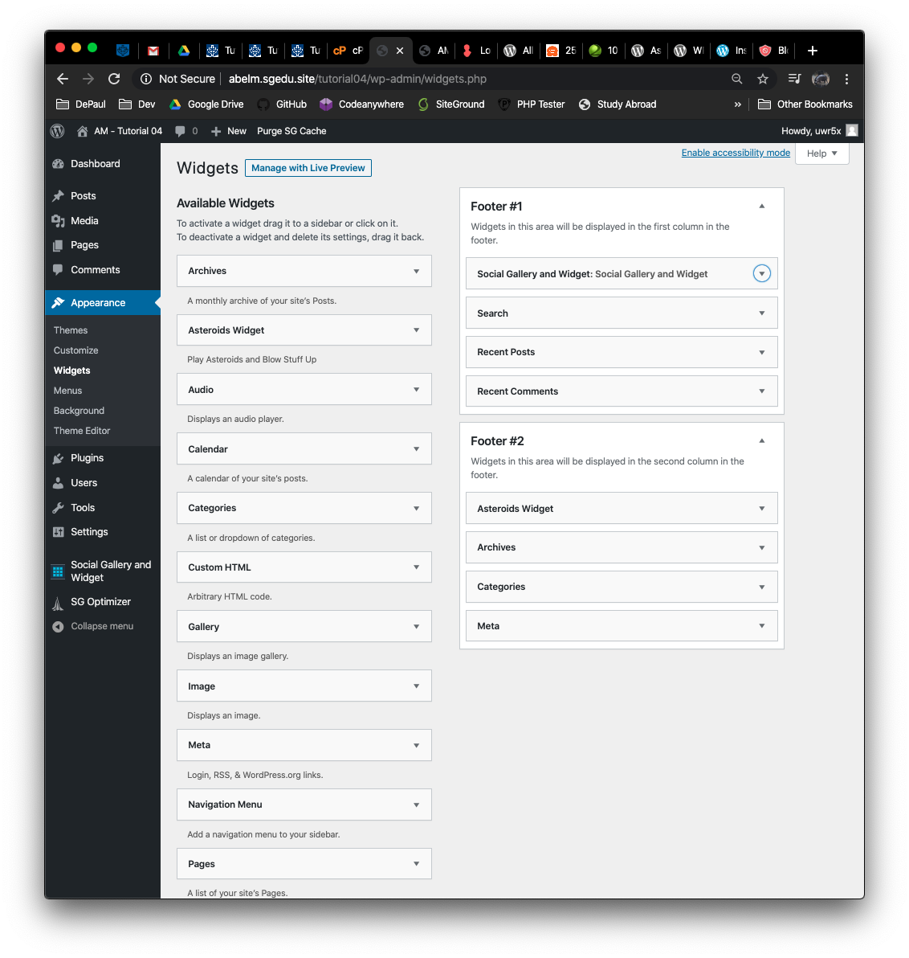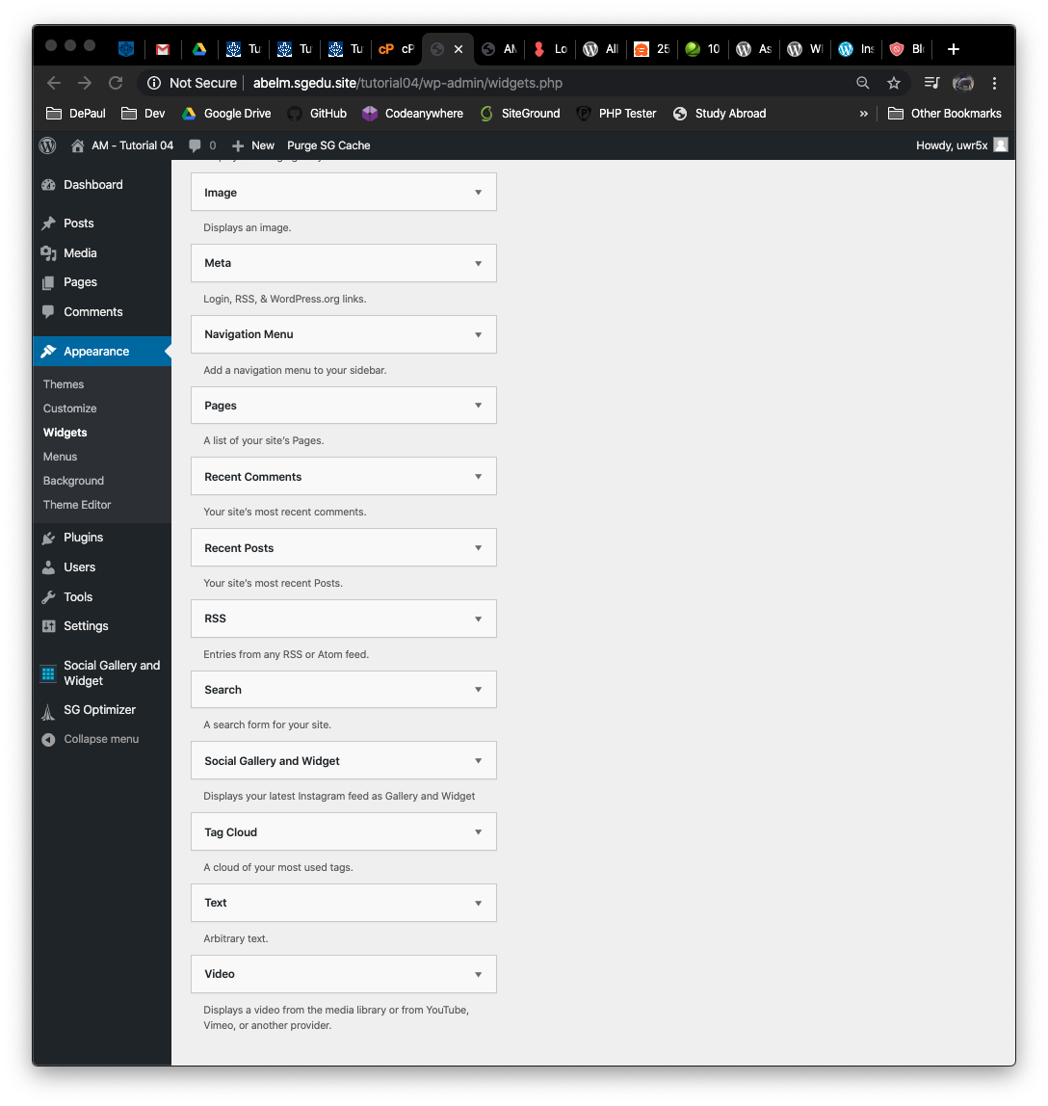]**

**Go back to the instructions and continue at Part E.**

**Part E – Comments and Discussion**

**Please make sure all Part E screen capture include the web browser address bar. [E]**

1. Take screen captures of the backend administration WordPress site Dashboard > Posts  
    showing post comments **[E.1]  
   [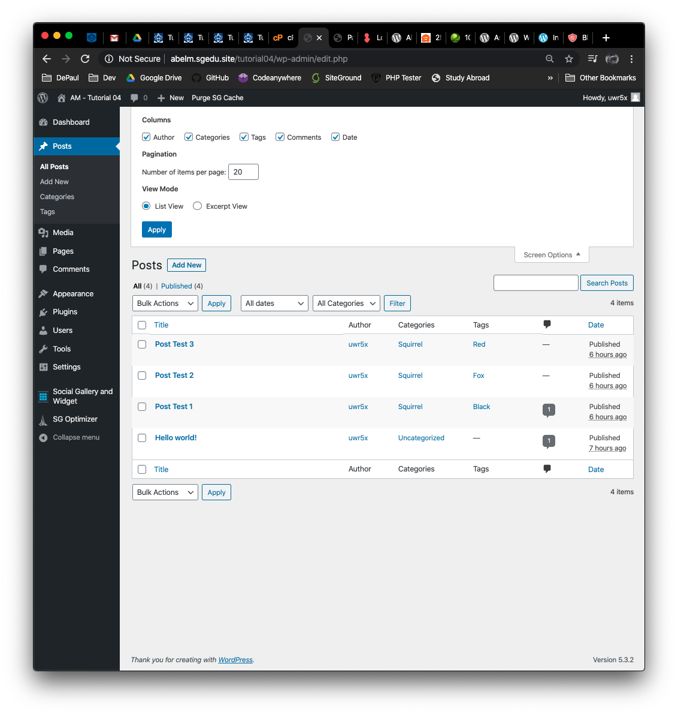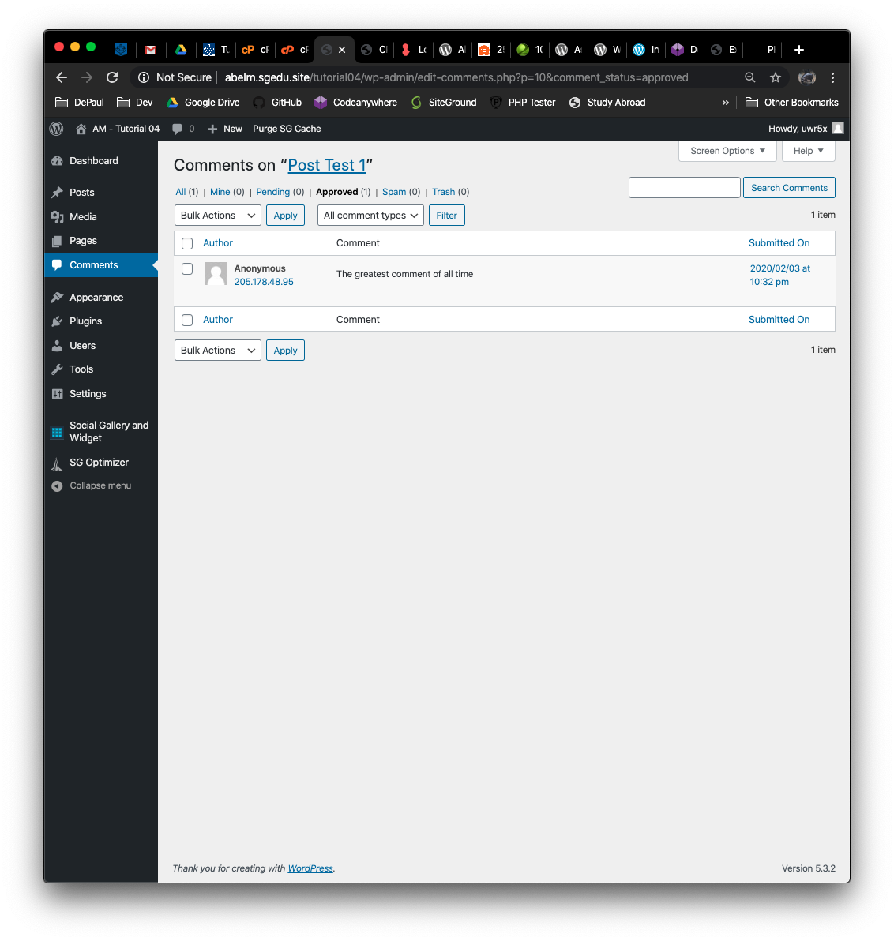]**
2. Take screen captures of the backend administration WordPress site Dashboard > Pages **[E.2]  
   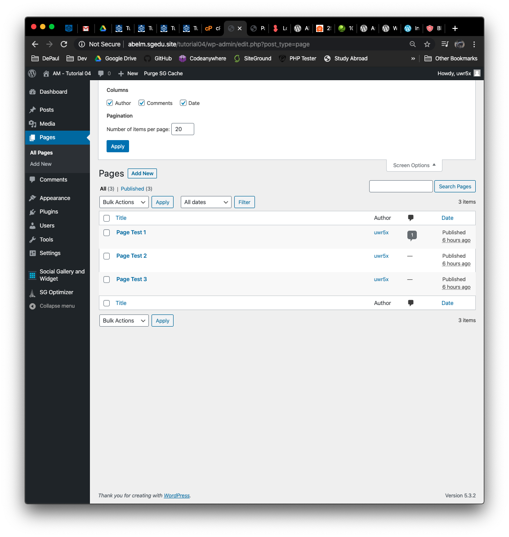[]**
3. Take screen captures of the backend administration WordPress site Dashboard > Settings > Discussion page **[E.3]  
   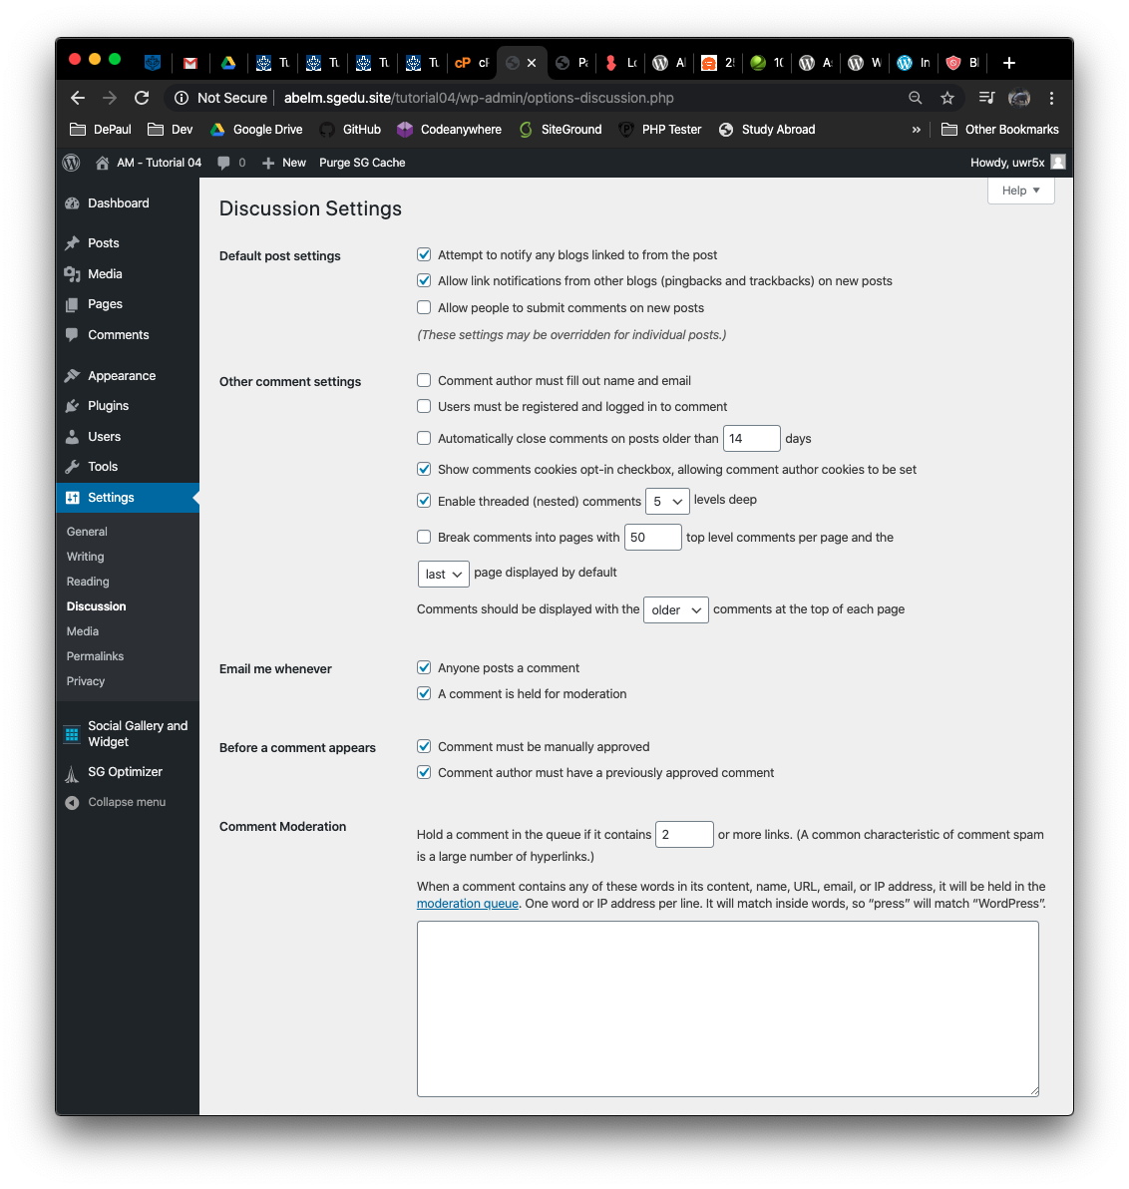[]**

**Go back to the instructions and continue at Part F.**

**Part F – Migrations**

**Please make sure all Part F screen capture include the web browser address bar. [F]**

1. Take screen captures of the backend administration WordPress site Dashboard > Plugins **[F.1]  
   [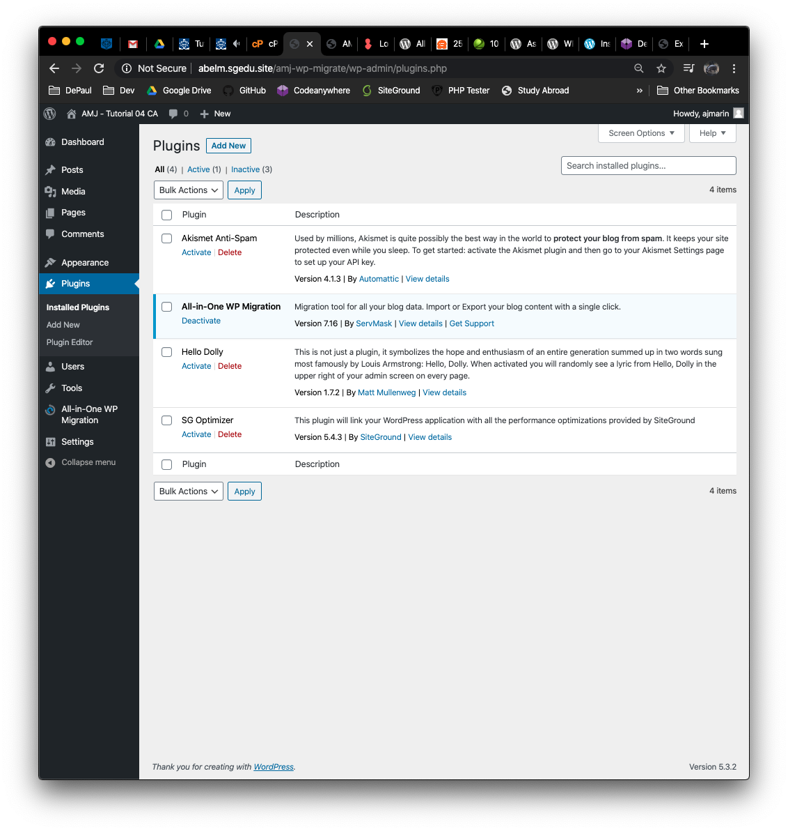]**
2. List the source and destination platforms here. The source platform is the name of the shared web host that you build and configure the original Word Press site. The Destination platform is the name of the web host that you migrated the WordPress site to. **[F.2]  
   Source Platform: [ Codeanywhere ]   
   Destination Platform: [ SiteGround ]**
3. Was the migration successful? **[F.3]  
   [ Yes ]**
4. If you answered No to the previous question, please record any errors, or information on what happened. And if you have not done so already, please contact the instructor for help, so you do not lose points on the assignment, which also has a WordPress migration? **[F.4]  
   [ What went wrong?]  
   [You can put screen captures here also ]**
5. Front-end screen capture of the destination site home page. **[F.5]  
   [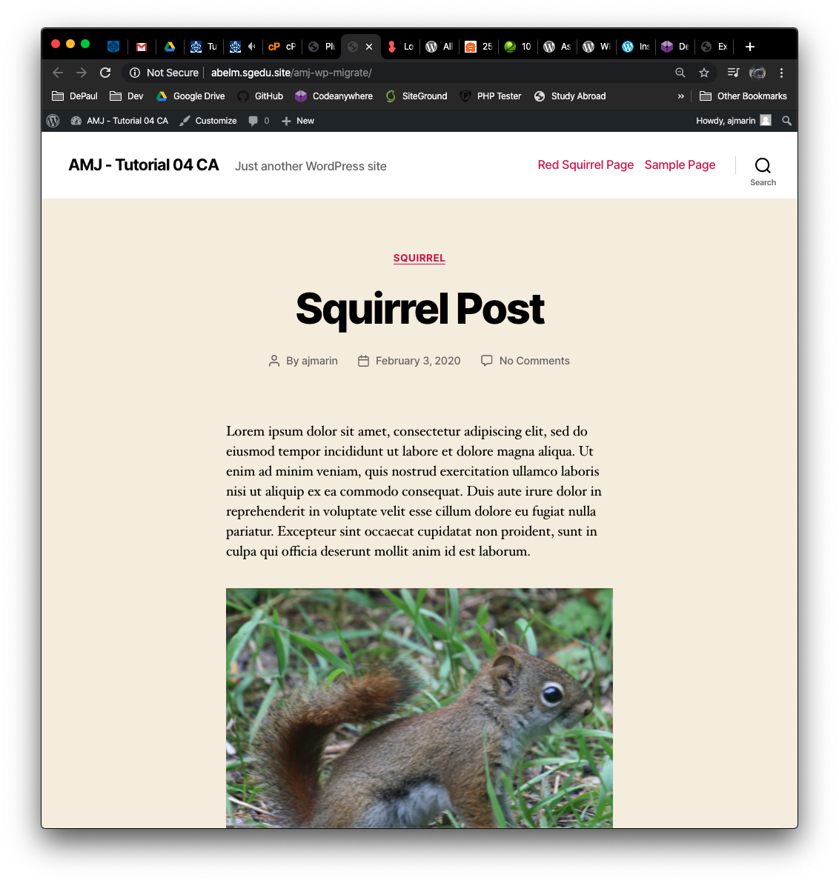]**
6. Destination Website site and login credentials**:**
   1. Website URL: [ http://abelm.sgedu.site/amj-wp-migrate/ ]
   2. Website Admin Username: [ ajmarin ]
   3. Website Admin Password: [ $FfWI$RZUdut2XqieM ]

**Go back to the instructions and continue at Part G.**

**Part G – Custom Modules**

**Please make sure all Part G screen capture include the web browser address bar. [G]**

1. Take screen captures of the cPanel > FILES panel > File Manager > WordPress site folder, with the wp-content/plugins folder and custom plugin folders **[G.1]  
   [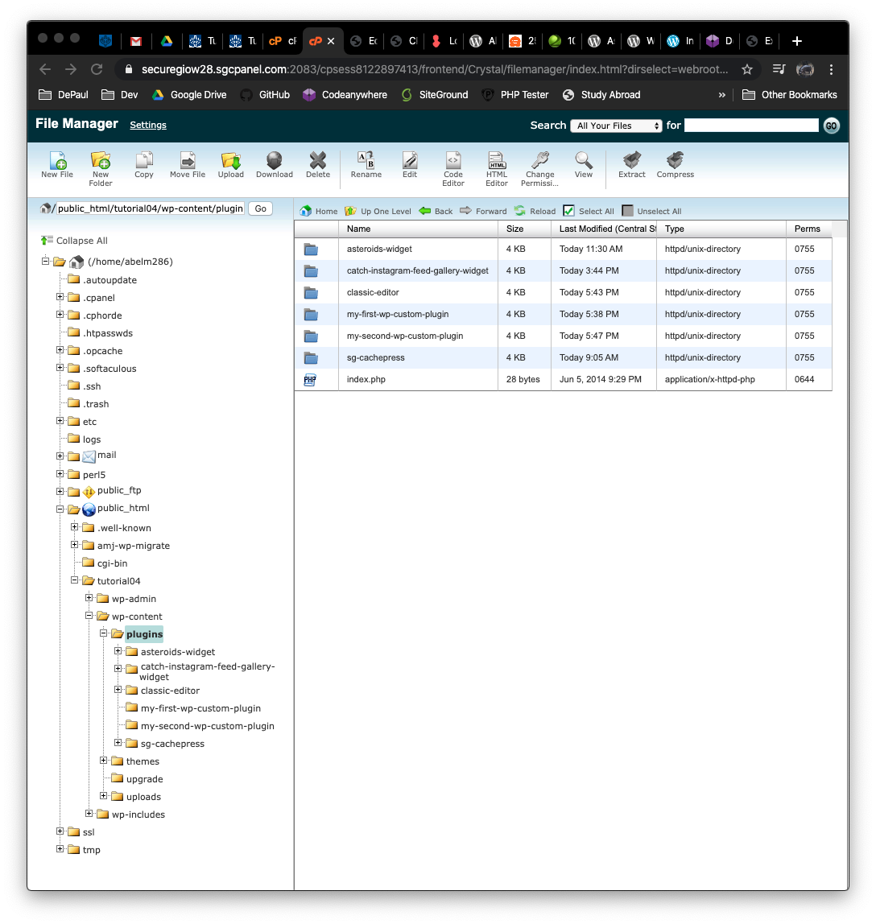]**
2. Take screen captures of the backend administration WordPress site Dashboard > Plugins showing the two custom plugins enabled **[G.2]  
   [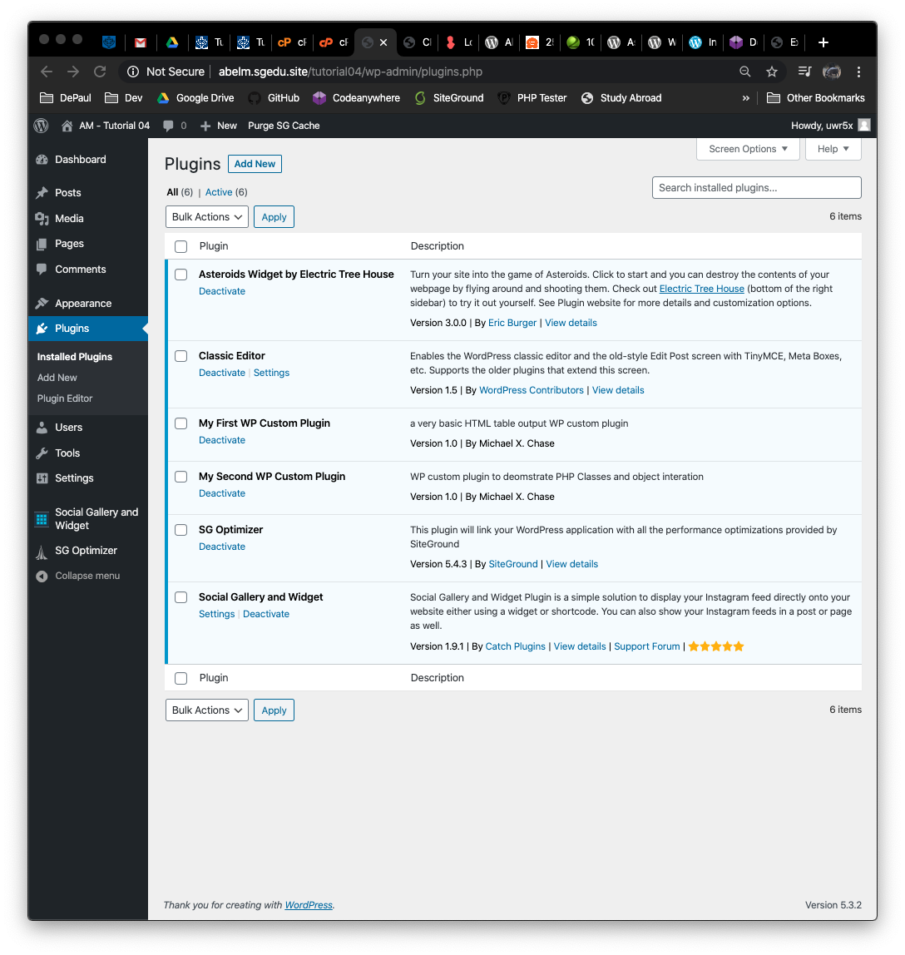]**
3. Take screen captures of the backend administration WordPress site Dashboard > Pages **[G.3]  
   [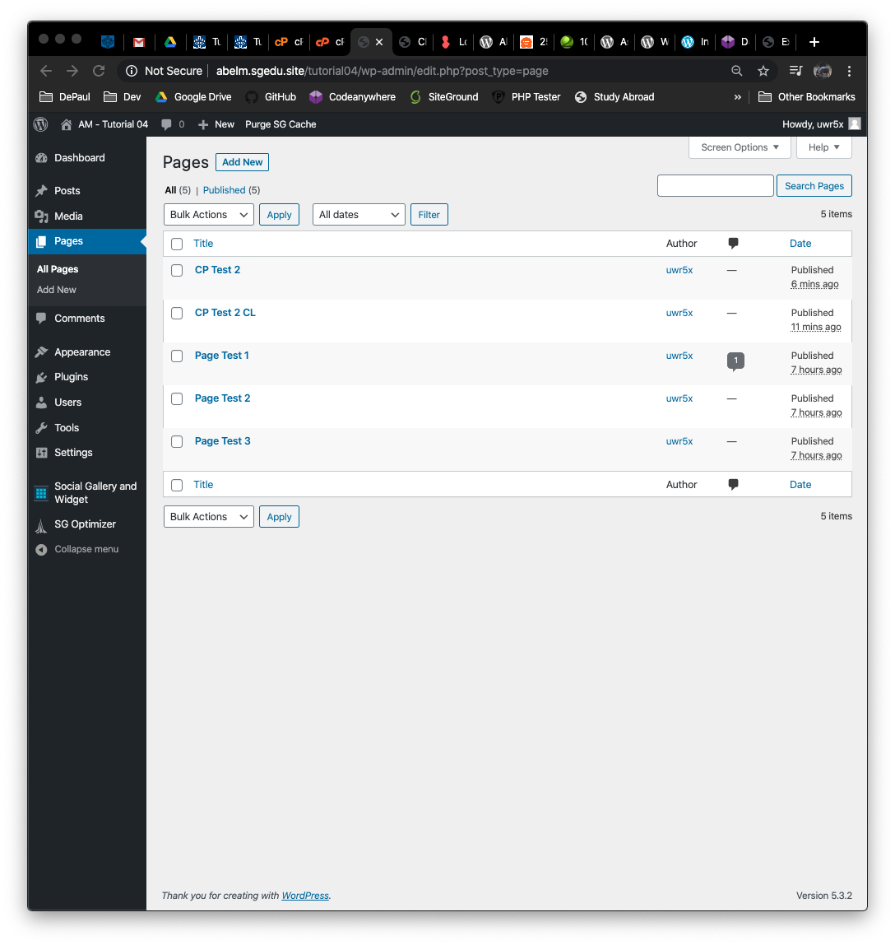]**
4. Front-end screen capture showing the First Custom Plugin page out.  
   Please verify that your screen capture shows the web browser address bar **[G.4]  
   [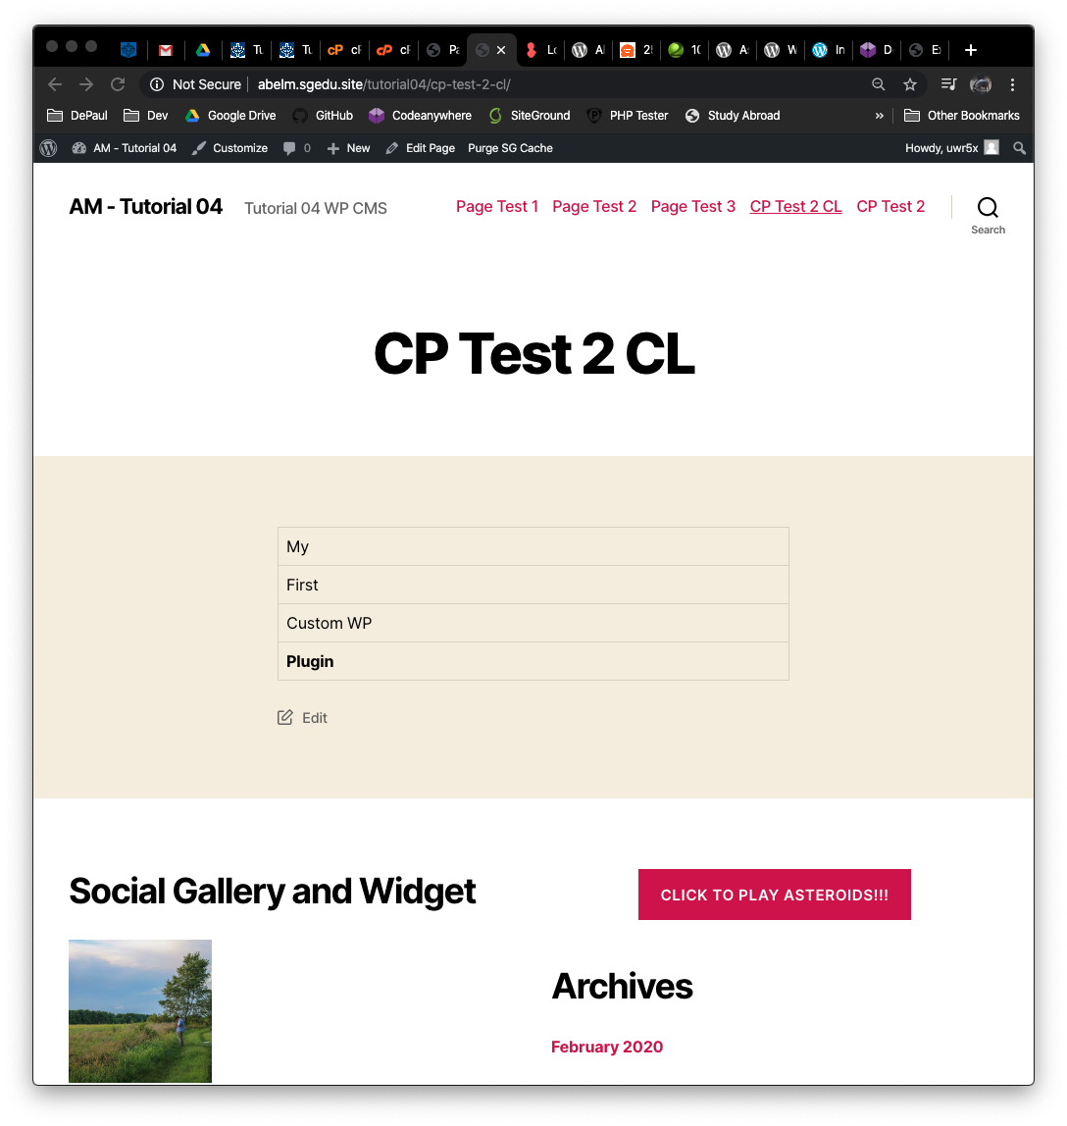]**
5. Front-end screen capture showing the Second Custom Plugin page out.  
   Please verify that your screen capture shows the web browser address bar **[G.5]  
   [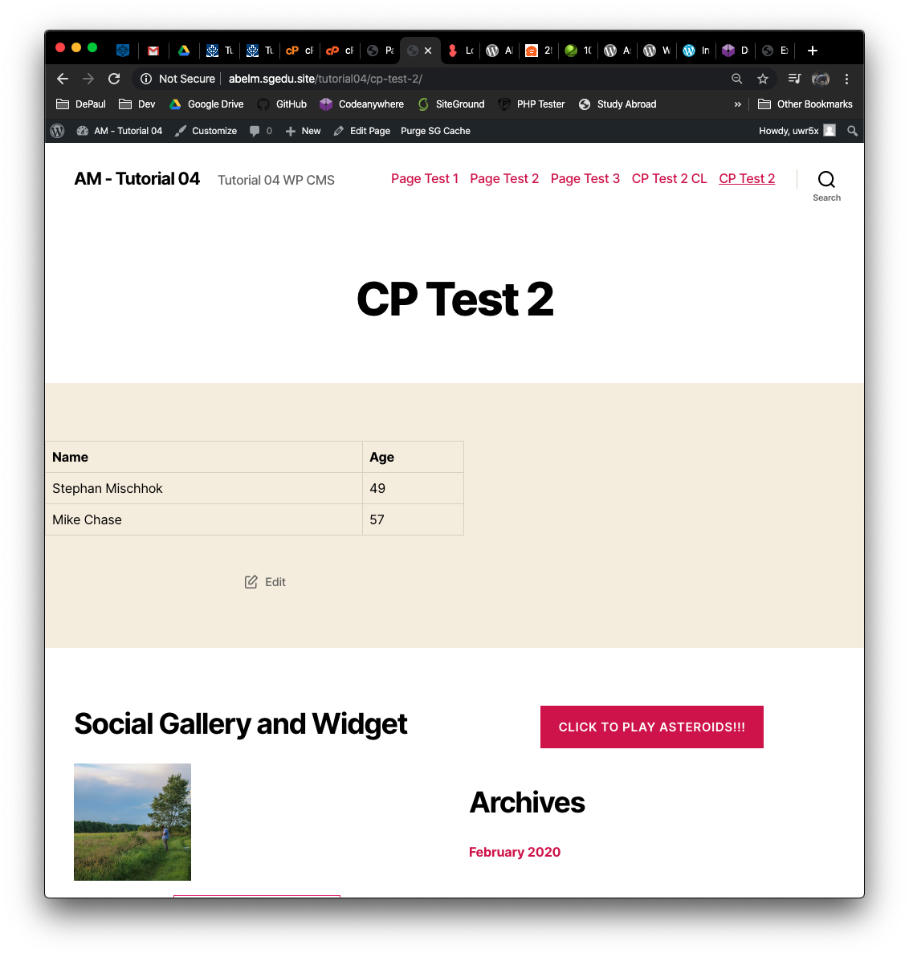]**

**Go back to the instructions and continue at Part H.**

**Part H – PHP QUESTIONS**

**Testing PHP Programs using PHP Emulation Websites:**

* Online PHP test sites:
  + <http://phptester.net>
  + <http://sandbox.onlinephpfunctions.com/>
* How you test your script depends on which test site you use.
* **Each PHP emulation test site works slightly different**.
* Please read the site instructions before testing your PHP code.

1. Write and test PHP code that does the following:
   1. Creates a PHP class named dog with member variables named breed (string), size (string) and intelligence (integer 1-5). Create get and set methods for all member variables. Write code that creates a dog object named Husky and set all member variables to values of your choice and echo each objects values by calling the objects get methods.
   2. **Test your code using an online PHP emulator and paste the code and results in the table cell below.**

|  |
| --- |
| Copy and paste the code block and record the results on the next row. A screen shot from the PHP test site will be the best way to not affect template format. Please try not to change the template numbering or format. |
|  |

1. Examine the image below and answer the following questions is the function argument $num a default argument or an optional argument? Is the function argument pass by reference or pass by value?

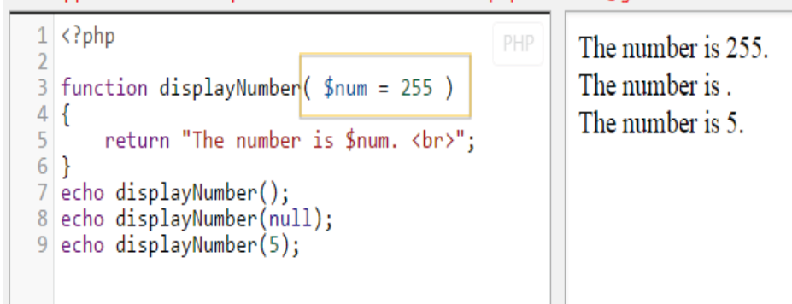

|  |
| --- |
| 1. Is the function argument a default argument or an optional argument? |
| $num is a default argument. |
| 1. Is the function argument pass by reference or pass by value? |
| $num is pass by value. |
|  |

1. Examine the image below and answer the following questions about the function arguments $flavor and $type. Define each argument as either regular, default, or optional.   
   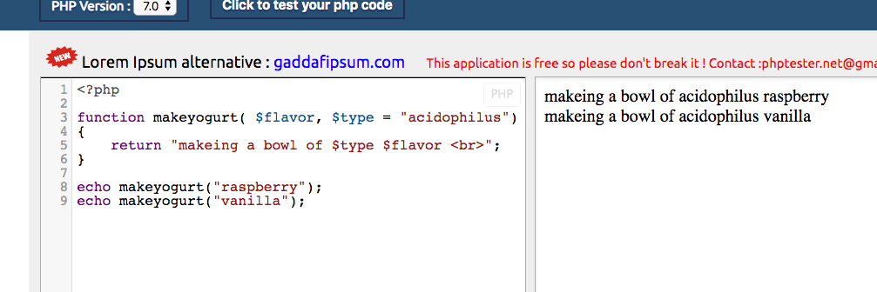

|  |
| --- |
| 1. Is the function argument $flavor a regular, default, or an optional argument? |
| $flavor is a regular argument. |
| 1. Is the function argument $type a regular, default, or an optional argument? |
| $type is a default argument because it has a value associated with it. |
|  |

**Please go back to the instructions and work on Part I.**